Laboratory L01 – HTTP
1. For the selected website, show the curl command. Show the content of the headers and the response body.
Example 1: curl -i http://wikipedia.org
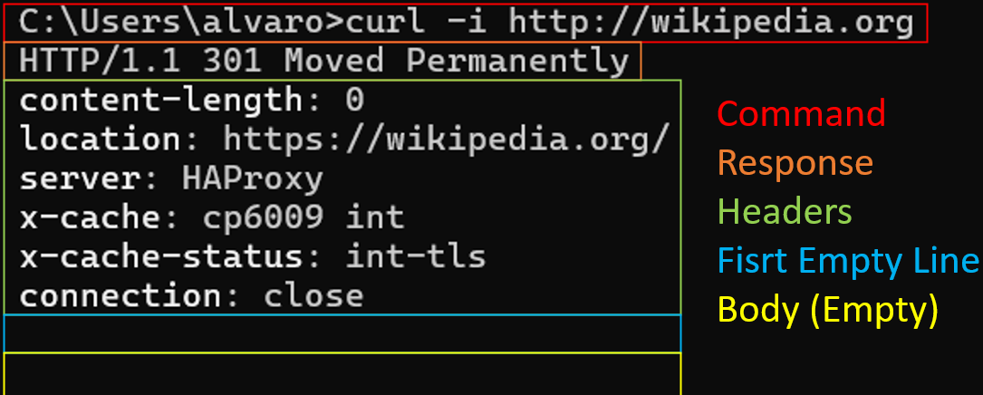
Example 2: curl -i https://en.wikipedia.org/wiki/Main_Page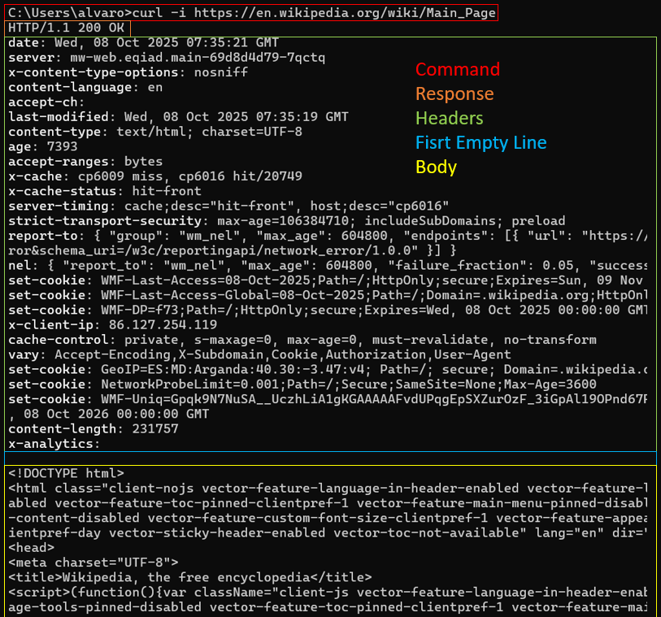
2. For the selected website, show the operation of the developer tools of the selected browser. Show what requests the browser has sent and what responses it has received. Present the type of request, its header and body. Do the same for the response.
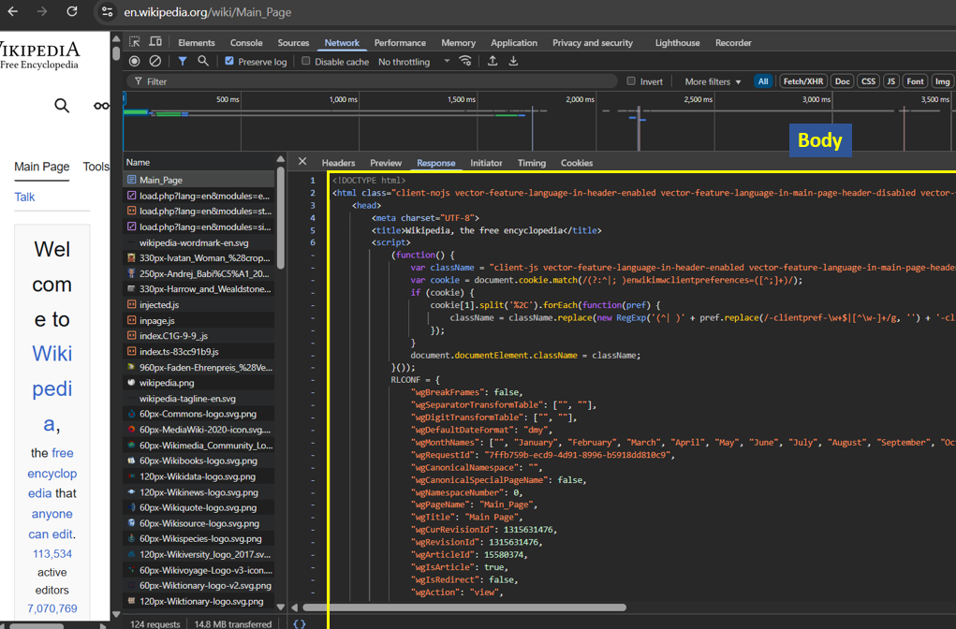
Web page: https://en.wikipedia.org/wiki/Main_Page
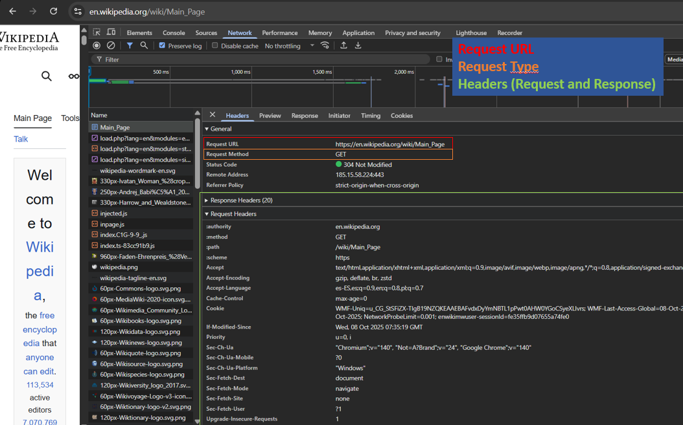
3. Find the page using the query string in the URL and show the action by typing a new query string from the keyboard.
For using the query string, we must access to the View History tab in Wikipedia so the URL changes to: https://en.wikipedia.org/w/index.php?title=English_Wikipedia&action=history
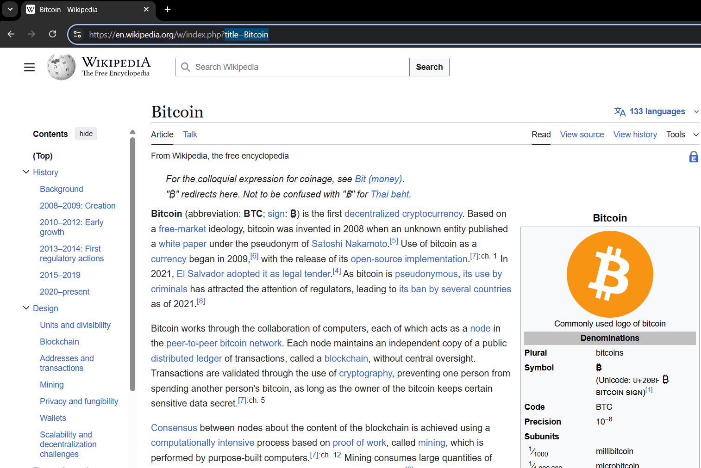
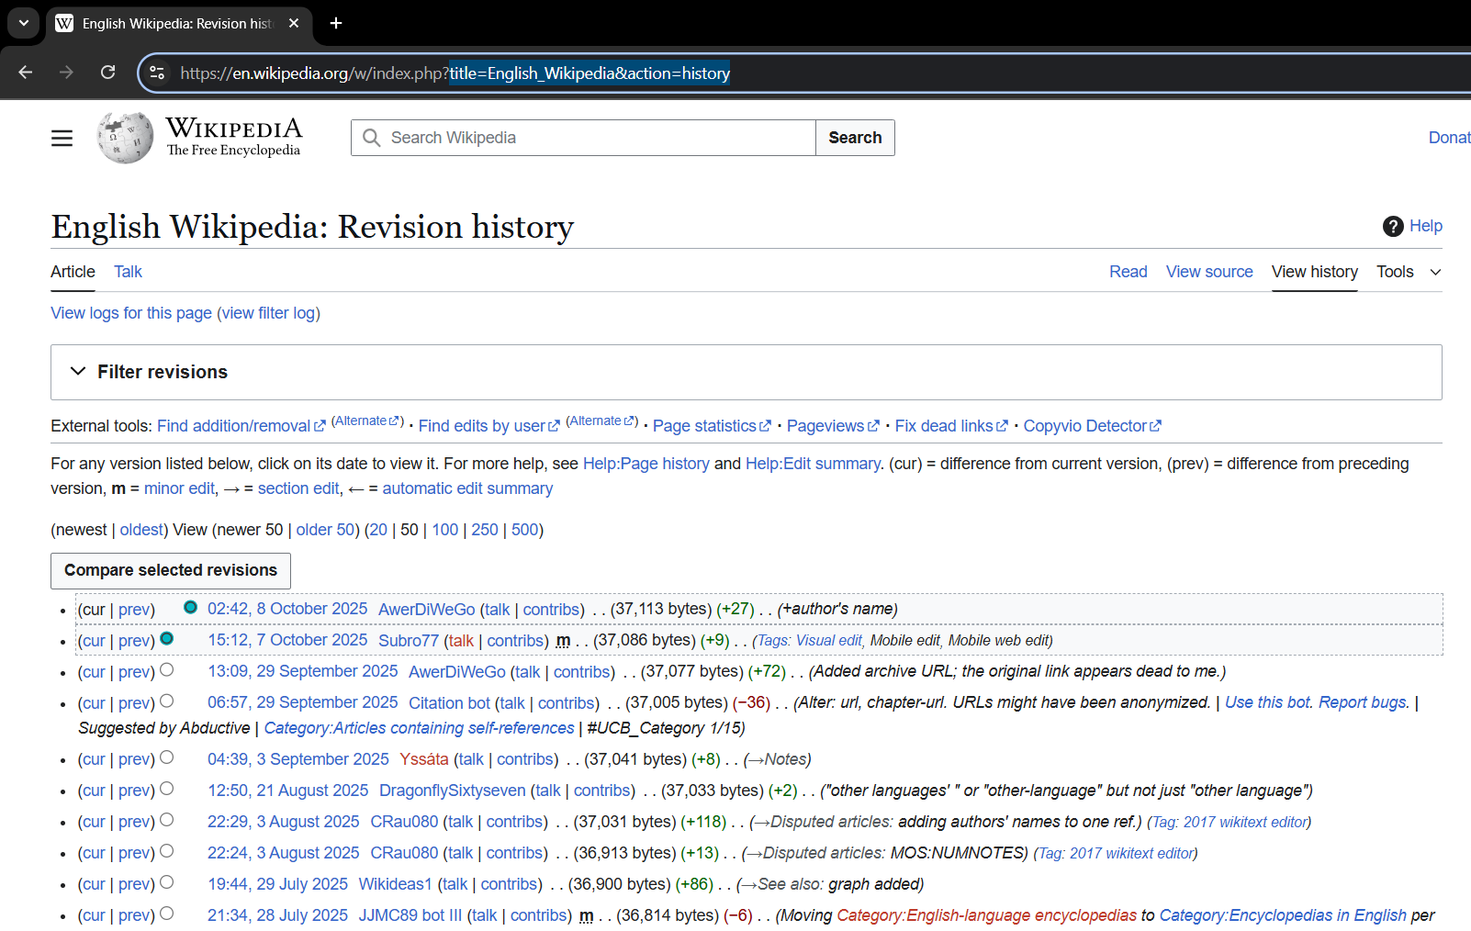
So “https://en.wikipedia.org/w/index.php?title=English_Wikipedia” and “https://en.wikipedia.org/w/index.php?title=English_Wikipedia” reach the same content, so If you change the title=English_Wikipedia to title=Bitcoin you now can access another page:
4. Find the page with the form that submits the data in the body of the POST type request. Demonstrate that this is indeed the case.
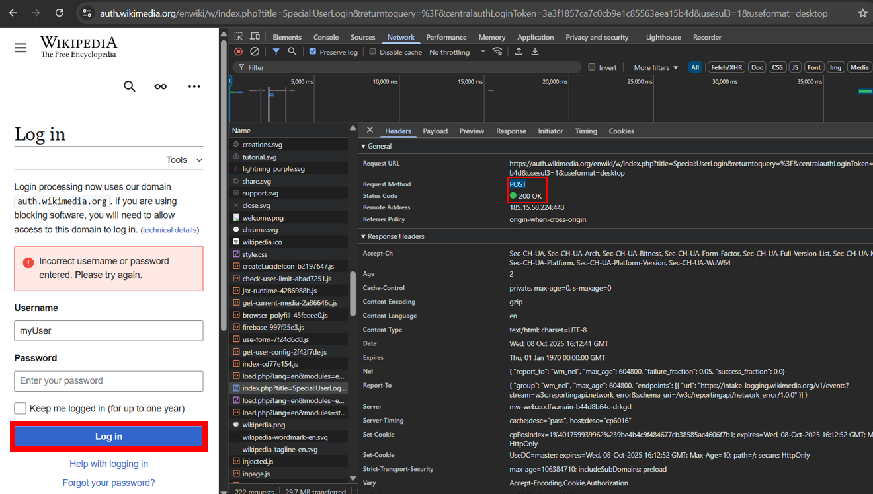
Open the log in at: https://en.wikipedia.org/w/index.php?title=Special:UserLogin
After adding an email and a password clicking Log in. We see a connection POST that sent the “myUser” and “myPass” fields to the server, which sent back the HTML of the page with the error message.
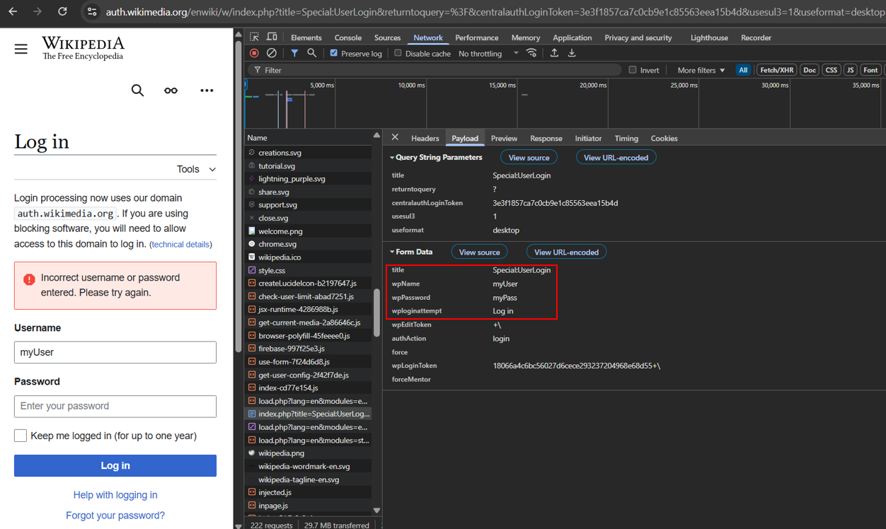

5. Create your own valid website (or more pages), which will include:
a. title,
b. tags for different types of headers,
c. text in paragraphs,
d. comments,
e. Linked:
i. other websites,
ii. pictures,
iii. some zipped file,
iv. e-mail adress
Done in the folder web.

6. Show with the selected validator that the page is correct.
By entering in: https://validator.w3.org/#validate_by_upload+with_options
